**SUPER MARCKET SALES SQL QUERIES**

**Show data in table.**

select * from supermarket_sales

**KPI’S**

**Total sales price**

select round(sum(Total),0) as Total_sales_price from supermarket_sales



**Cogs**

select round(sum(cogs),0) as Total_cogs from supermarket_sales

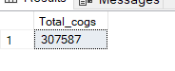

**Total gross income**

select round(sum(gross_income),0) as Total_gross_income from supermarket_sales

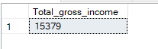

**average Gross margin percentage**

select round(avg(Gross_margin_percentage),2) as average_gross_margin_percentage from supermarket_sales



*If we need to add filters here, we can use “where” clause.*

select round(avg(Gross_margin_percentage),2) as average_gross_margin_percentage from supermarket_sales

where Branch = 'A'

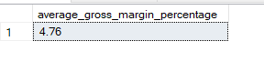

**Ratings**

select round(avg(rating),2) as average_rating from supermarket_sales



**Average rating percentage**

select round((sum(rating)/count(invoice_ID))*10,0) as average_rating_percentage from supermarket_sales

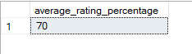

**Product line by quantity**

select Product_line ,sum(quantity) as Total_quantity from supermarket_sales

Group by Product_line

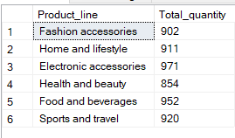

*If we need get product line by quantity in each branch****,***

select Product_line ,sum(quantity) as Total_quantity from supermarket_sales

where Branch = 'A'

Group by Product_line

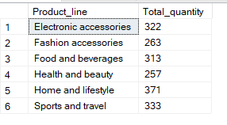

select branch,Product_line , sum(Quantity)from supermarket_sales

where Branch in ('A','B','C')

group by Product_line , Branch

order by branch

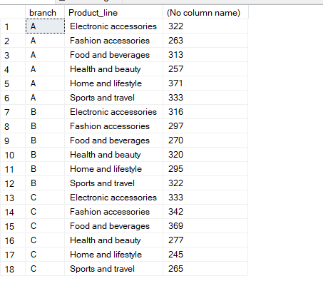

**Product line by Gender**

select Gender ,Product_line ,count(Gender) as Total from supermarket_sales

group by Product_line ,Gender

order by Product_line ,Gender

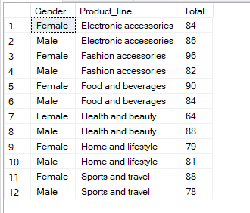

**Product line by average unit price**

select Product_line , round(avg(unit_price),0) as avg_unit_price from supermarket_sales

group by Product_line

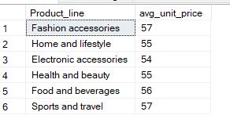

**Tax by branch**

select Branch ,Product_line , round(sum(tax),0) as Total_tax from supermarket_sales

group by Branch,Product_line

order by Branch

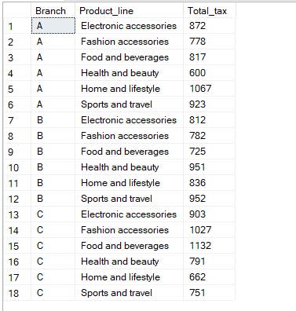

**product line by total gross income in each city**

select city , Product_line , round(sum(gross_income),0) as Total_gross_income from supermarket_sales

group by Product_line , city

order by city

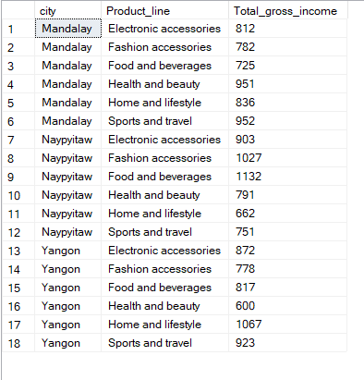

**month wise total sales price, total gross income, total quantity**

select datename(month,Date) as Sales_month ,

round(sum(Total),0) as Total_sales_price ,

round(sum(gross_income),0) as total_gross_income ,

sum(Quantity) as total_quantity from supermarket_sales

group by datename(month,Date)

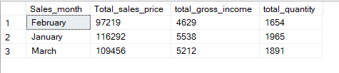

**Quantity by time**

select datepart(hour , time) as time , sum(Quantity) as quantity from supermarket_sales

group by datepart(hour , time)

order by datepart(hour , time)

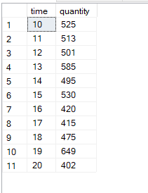

**customer type by payment method**

select Customer_type , Payment , count(Payment) as Total from supermarket_sales

group by Customer_type , Payment

order by Payment

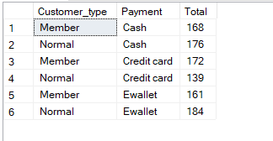

select Payment ,count(Payment) as total from supermarket_sales

group by Payment

